Development log

Friday:

The work started on Friday with the ideas about what the project would be about and the decision was made to talk about Mexican art, its history and importance within the country and from there we started to work on how the web page would be integrated and what information to put in it.

There was a fight between several styles of art to be represented or if it was better to talk about several and better the decision was made to talk more specifically about one and there we saw whether to look between Asian, African or a more Renaissance style but finally won the Mexican style or art which at times is forgotten or not taken the importance it should have.

Saturday:

On the second day it was decided how the page would be distributed and its layout, since there were several ideas and it was decided that the main page would talk a little about the importance in the history and some other important information of the company.

We worked on it and in the formats of contacting or creating your account to know a little more about it and also decide on which artists represented the Mexican style and their great works.

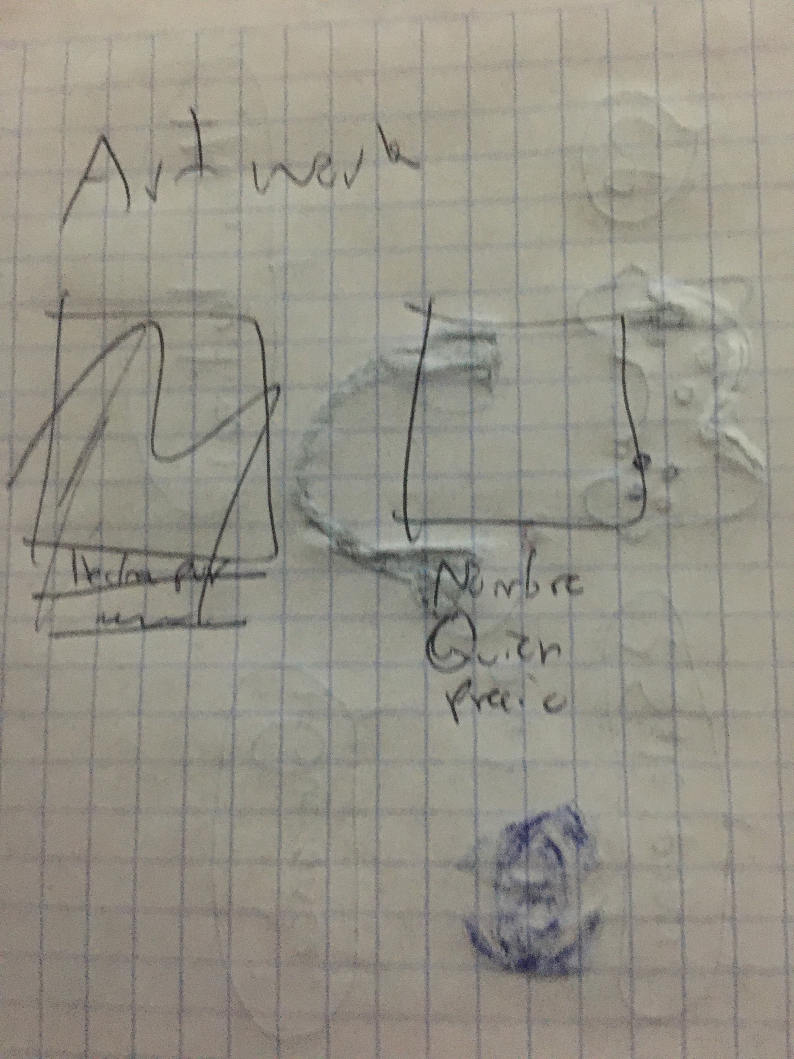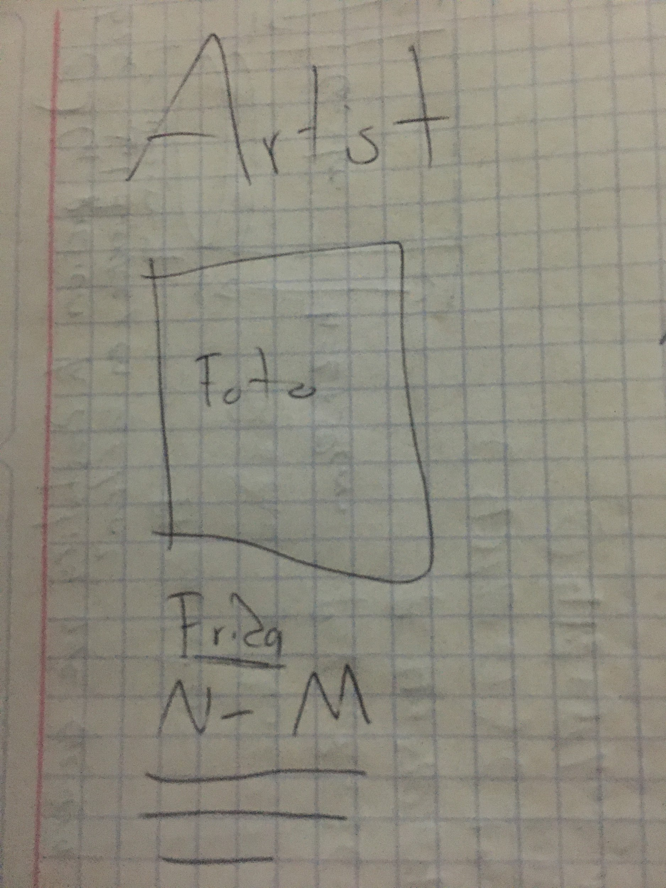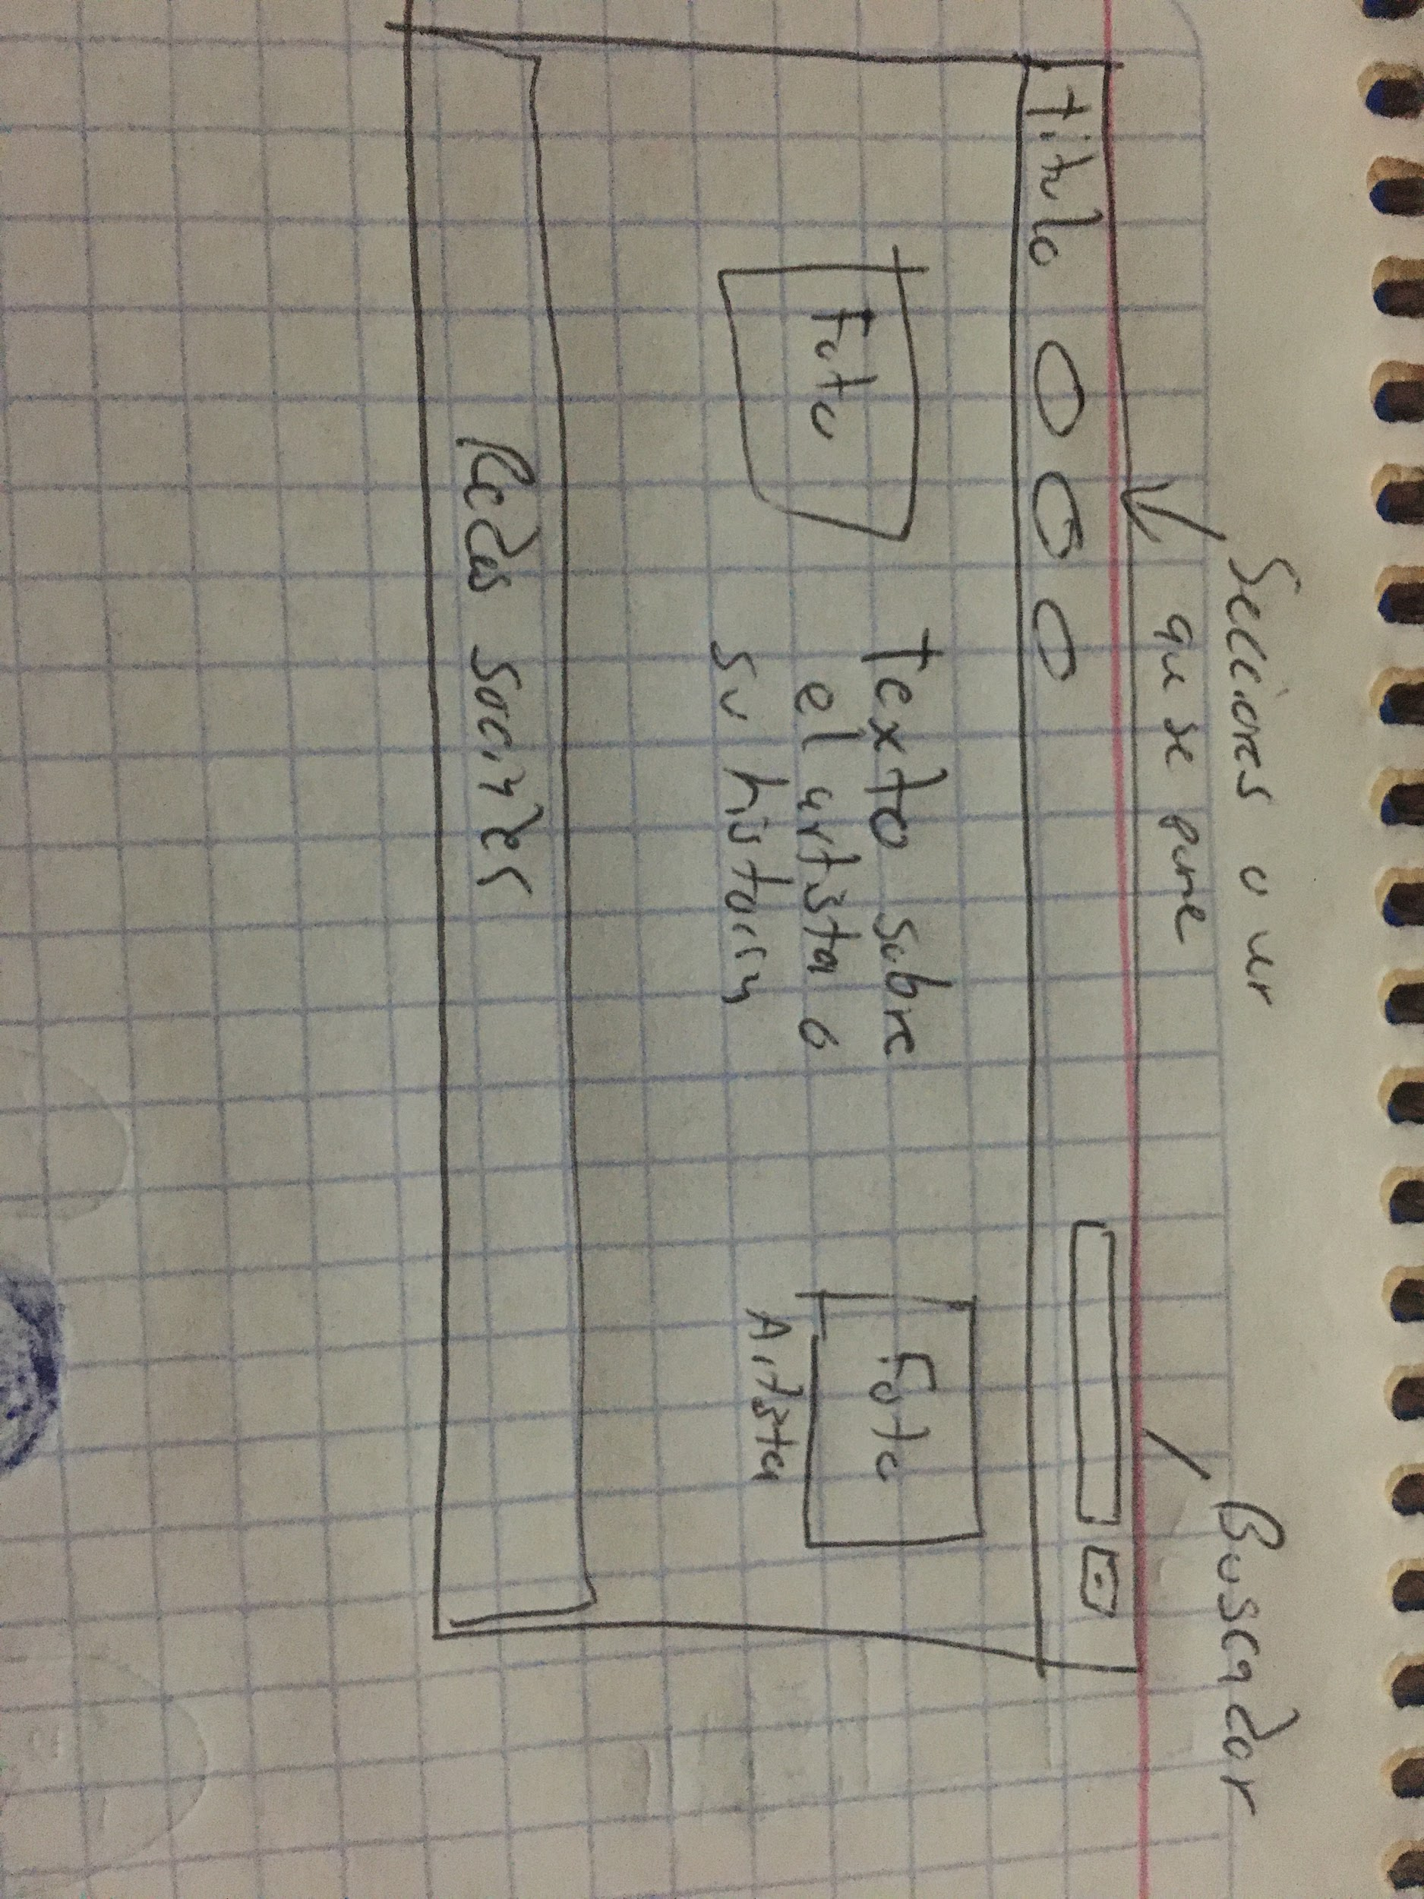

Sunday:

On the last day we worked to make it look nice aesthetically and also that it worked well on the phone and one or another detail that had the page to make it functionally and aesthetically well, we investigated some information about the museums and that everything looked good.

